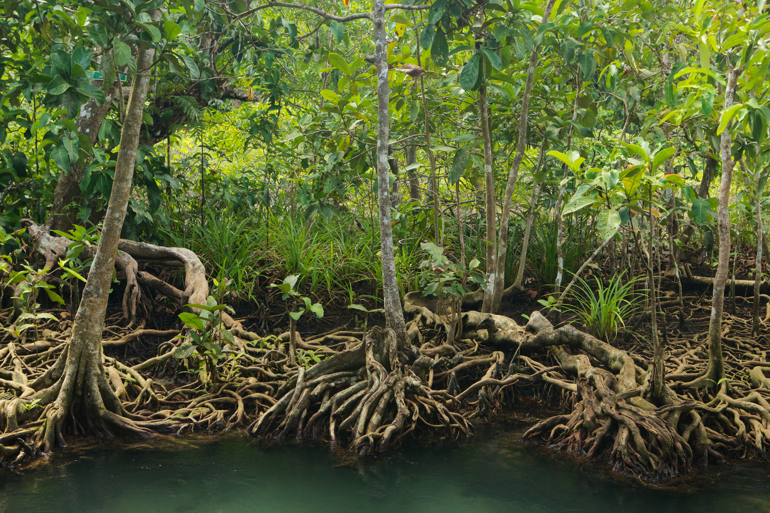

*ASEAN-UK Green Transition Fund Technical Proposal template*

Project title:

[Publish Date]

**Table of Contents**

1. Consortium 4

2. Executive summary 4

3. Work package 5

4. Background 5

5. Methodology 6

6. Theory of Change (ToC) 7

7. Expected results 8

7.1. Impact 8

7.2. Outcomes and intermediate outcomes 9

7.2.1. Outcomes 9

7.2.2. Intermediate outcomes 9

7.3. Outputs 10

7.4. Monitoring, learning and communications plan 12

7.4.1. Indicators 12

7.4.2. Monitoring approach 14

7.4.3. Learning and communications approach 15

8. Workplan and budget 15

9. ASEAN stakeholders 16

9.1. Key stakeholders 16

9.1.1. ASEAN Secretariat engagement plan 16

9.1.2. ASEAN Working Groups engagement plan 16

9.1.3. Other Stakeholders’ engagement plan (including entities associated with ASEAN) 17

10. ASEAN priority 17

11. Inclusivity 18

11.1. Poverty alleviation 18

11.2. GEDSI empowerment or transformation 18

12. Additionality 19

13. Governance, knowledge, skills, experience, and team structure 20

13.1. Team 20

13.1.1. Organogram 20

13.2. Mandatory and relevant company experience 21

13.3. Internal governance 23

14. Value for Money (VfM) 23

15. Project management 24

15.1. Project management 24

15.2. Environmental sustainability 25

15.3. Risk management and mitigation 26

16. Signature 26

1. Consortium

Describe your consortium's configuration and specify each partner's involvement and roles. Please submit the proof of office legal registration and the letter of intent to form a consortium.

|  |  |  |  |
| --- | --- | --- | --- |
| Partner name | Description of key roles and involvement within the consortium | Office Legal Registration | Additional observations |
| *(E.g.X Company Ltd)* | *(E.g. Consortium lead)* | *(E.g. Singapore city, Singapore)* | *(E.g. X company will provide international best practice while leading the day-to-day project management)* |
|  |  |  |  |

1. Executive summary

Brief overview of the project, including its core objectives, significance, alignment with the ToR and expected outcomes. **(Max. 350 words)**

|  |
| --- |
|  |

1. Work package

Insert the selected work package and pillar of your project. Example: *[Pillar I Climate Policy – Work Package I.3 NDC and Article 6]*. Should the applicant submit multiple bids responding to several work packages, please insert the details in this chapter and the VfM (Value for Money) chapter 14.

|  |
| --- |
|  |

1. Background

Please provide a brief description of the project context, detail the specific problem(s) or barrier(s) the project addresses and mention how they relate with those defined in the terms of reference (ToR). **(Max. 300 words)**

|  |
| --- |
|  |

1. Methodology

Description of the core approach that will be taken to meet project objectives. Please also list any relevant methodologies, tools, etc. that will be applied/used to achieve what the project aims to deliver. **(Max. 800 words)**

|  |
| --- |
|  |

1. Theory of Change (ToC)

Please complete the separate ToC template for your project (PPT template) and paste an image of the diagram below. Ensure that you also submit the completed template along with your proposal.

**ToC diagram:**

|  |
| --- |
|  |

1. Expected results

In the sections below, you must outline the results, outputs, intermediate outcomes, outcomes and impact expected from project implementation. These should align with the broader outcomes detailed in the Call for Proposals /Terms of Reference (ToR) and your project Theory of Change (ToC). All results should be measurable and time-bound. In the subsequent section, you will be asked to detail how you intend to monitor and measure progress towards achieving these results.

1. Impact

Impacts are the long-term, high-level and significant changes or goals to which your project is expected to contribute. These changes can be social, economic, environmental or institutional and reflect the broader, often transformative changes[1] of project delivery.

Describe the overall impact goal towards which your project will contribute. This should align with the broader impact goal outlined in the ToR.

|  |  |
| --- | --- |
| Impact statement | Can it be measured during project implementation? (Y/N) |
|  |  |

1. Outcomes and intermediate outcomes
2. Outcomes

Outcomes are the specific and measurable short- to medium-term changes in target systems, organisations, institutions, behaviours, conditions, capital flows, relationships, or arrangements in which project outputs are expected to result. Outcomes are not always delivered during the lifetime of a project, but evidence of progress towards them should be seen. Projects can have one or several outcomes. However, it is recommended that the projects do not have more than three outcomes.

Describe the outcomes the project aims to achieve. All outcomes should be linked to the project’s impact, intermediate outcomes and outputs, and aligned with the outcomes outlined in the ToR.

|  |  |  |  |
| --- | --- | --- | --- |
| Outcome number | Outcome statement | Deliverables and/or evidence | Target date of accomplishment |
| O1 |  |  |  |
| O2 |  |  |  |
| O3 |  |  |  |

1. Intermediate outcomes

The jump from outputs to outcomes in capacity-building and policy change interventions can be significant. Intermediate outcomes can help track progress towards outcomes by providing interim indications of target stakeholders' initial uptake and application of project outputs. We most commonly expect to see, measure, and report intermediate outcomes after an output has been delivered. They reflect the specific skills, knowledge, networks, and capacities stakeholders wish to build or enhance, as well as how they intend to act upon these.

Describe the intermediate outcomes the project aims to achieve. All intermediate outcomes should be linked to the project’s impact, outcomes and outputs, and aligned with the outcomes outlined in the ToR.

|  |  |  |  |
| --- | --- | --- | --- |
| Intermediate outcome number | Intermediate outcome statement | Deliverables and/or evidence | Target date of accomplishment |
| IO1 |  |  |  |
| IO2 |  |  |  |
| IO3 |  |  |  |
| … |  |  |  |

1. Outputs

Outputs are the products, deliverables or services resulting from project activities. Outputs are within the direct control of an intervention and are normally provided to the project’s key counterparts or other project stakeholders. Outputs are the basis from which the desired change will occur, e.g., trainings delivered, policy recommendations produced, knowledge generated and shared, tools developed and piloted, etc.

Describe the outputs your project aims to achieve. Note that all outputs on ASEAN-UK GTF projects should be aligned with the work package outlined in the ToR and should be categorized using the four programme output types once relevant:

* Technical capacity to design and deliver equitable green transition policy and action strengthened within and across ASEAN​
* Innovative models for climate action (including policy and novel technologies) developed and piloted within and across ASEAN​
* Knowledge, evidence and learning generated and exchanged across stakeholders in ASEAN​ in support of improved climate action
* Effective partnerships established and strengthened to enable action-oriented convening and influencing on climate across ASEAN

|  |  |  |  |  |  |  |
| --- | --- | --- | --- | --- | --- | --- |
| Output number | Output name | Output type* | Target stakeholders | Output description | Deliverables and/or evidence | Target date of accomplishment |
| OU1 |  |  |  |  |  |  |
| OU2 |  |  |  |  |  |  |
| OU3 |  |  |  |  |  |  |
| OU4 |  |  |  |  |  |  |
| OU5 |  |  |  |  |  |  |
| … |  |  |  |  |  |  |

*Please refer to the Project ToC Form slide 10

1. Monitoring, learning and communications plan
2. Indicators

Please describe the indicators proposed to monitor and measure progress against the output, intermediate outcome, outcome and impact results you listed above. Indicators can be qualitative or quantitative metrics, and should be ‘SMART’ - specific, measurable, accurate, regular, and time-bound. The data under these performance indicators support project management, decision-making, and accountability to UK PACT, as well as communicating project progress and results to external parties and stakeholders. These indicators may be refined during the co-creation phase to ensure they align with the UK PACT results framework.

Each result listed above should have at least one associated indicator, with milestones and targets for delivery over implementation. One indicator may, however, contribute to measuring progress against more than one result. Please ensure that you have included any relevant UK PACT programme indicators prescribed in the following list. Please also consider all pertinent disaggregation, for example, by gender, age or stakeholder group.

**UK PACT programme indicators:**

1. ICF KPI 15 – The extent to which contributes to likely Transformational Change
2. ICF TA KPI 5 – Volume of emissions reductions avoided or supported by international climate finance technical assistance
3. ICF KPI 11 and 12 – Volume of public and private finance mobilised for climate change purposes
4. ICF KPI 2 – Number of people and social institutions with improved access to clean energy
5. ICF KPI 7 – Installed capacity of clean energy
6. ICF TA KPI 3 – Number of climate policies informed by international climate finance technical assistance
7. ICF KPI 17 – Area under sustainable management practices

**Note:** for more information, you can visit [UK International Climate Finance results 2023 - GOV.UK (www.gov.uk)](https://www.gov.uk/government/publications/uk-international-climate-finance-results-2023/uk-international-climate-finance-results-2023)

**Indicator table**

|  |  |  |  |  |  |  |  |  |  |  |
| --- | --- | --- | --- | --- | --- | --- | --- | --- | --- | --- |
| **Summary of relevant performance indicators** | | | | | | **If applicable, contribution to specific ICF KPI number** | **Baseline** | **Target** | | |
| **#** | **Project Indicator Name** | **Associated Result/s  (e.g. I2, O3, IO1, OU4, etc.)** | **Means of verification Note: Please make sure to include the units of measurement** | **Disaggregation (if relevant)** | **Reporting Frequency** | **FY 25/26** | **FY 26/27** | **TOTAL** |
| **1** |  |  |  |  |  |  |  |  |  |  |
| **2** |  |  |  |  |  |  |  |  |  |  |
| **3** |  |  |  |  |  |  |  |  |  |  |
| **4** |  |  |  |  |  |  |  |  |  |  |
| **5** |  |  |  |  |  |  |  |  |  |  |
| **6** |  |  |  |  |  |  |  |  |  |  |

1. Monitoring approach
   1. Describe the project´s monitoring approach, including internal monitoring processes and systems **(Max. 200 words)**

|  |
| --- |
|  |

* 1. Describe any efforts for monitoring the context in support of achieving the project´s results **(Max. 200 words)**

|  |
| --- |
|  |

1. Learning and communications approach

Briefly describe any planned learning and communication activities for this project. Please include initial objectives of these activities, target audiences and how these activities would increase your project’s impact. **(Max. 300 words)**

**Note:** As part of these activities, applicants should plan to deliver at least one case study aligned with the UK PACT programme results framework. The case study concept note will be developed during the co-creation or inception stage.

|  |
| --- |
|  |

1. Workplan and budget

Please detail your planned activities, their target completion dates and associated costs within the separate ‘Budget and Workplan’ template. The template can be found on the **Fund’s webpage.**

1. ASEAN stakeholders

**Context:**

**ASEAN Secretariat:** The ASEAN Secretariat’s basic function is to provide for greater efficiency in the coordination of ASEAN organs and for more effective implementation of ASEAN projects and activities (ASEAN Secretariat, 2024). The list of the Secretariat Division can be accessed [here](https://asean.org/the-asean-secretariat-basic-mandate-functions-and-composition/organizational-structure-of-the-asean-secretariat-2/).

**ASEAN Sectoral Bodies:** ASEAN cooperation is manifested in ASEAN Sectoral Ministerial Bodies (see Annexe 1 of the ASEAN Charter). ASEAN Senior Officials Meeting assists their Sectoral Ministerial Bodies, which meet periodically to provide strategic guidance in advancing ASEAN cooperation on their thematic areas of cooperation. They lead the technical discussion and implementation of their respective Plans of Action. They are chaired by an ASEAN Member State, with a tenure of a specific period depending on the agreement of the respective Body.

**ASEAN entities:** The entities associated with ASEAN are accredited organisations that abide by the purposes, principles, policies, guidelines and other decisions of ASEAN. Accredited entities are obliged to support ASEAN’s objectives and purposes. These entities are listed under Annexe II of the ASEAN Charter (ASEAN Secretariat, 2024).

1. Key stakeholders
2. ASEAN Secretariat engagement plan

|  |  |  |  |
| --- | --- | --- | --- |
| ASEAN Secretariat Division | Type of participation in project planning | Type of participation in project implementation | Plan for maintaining ASEC support as the project progresses |
|  |  |  |  |

1. ASEAN Working Groups engagement plan

|  |  |  |  |
| --- | --- | --- | --- |
| ASEAN Working Groups | Type of participation in project planning | Type of participation in project implementation | Plan for maintaining ASEAN sponsoring bodies support as the project progresses |
|  |  |  |  |

1. Other Stakeholders’ engagement plan (including entities associated with ASEAN)

|  |  |  |  |
| --- | --- | --- | --- |
| Stakeholder | Type of participation in project planning | Type of participation in project implementation | Plan for maintaining stakeholder support as the project progresses |
|  |  |  |  |
|  |  |  |  |

1. ASEAN priority

Show how the proposed project requires regional action; and/or prioritised by relevant ASEAN Strategic Documents stated in the ToR. This is essential if the project is to be considered as an ASEAN cooperation project. **(Max. 300 words)**

|  |
| --- |
|  |

1. Inclusivity
2. Poverty alleviation

As an ODA programme, ASEAN-UK GTF’s overall objective is to alleviate poverty and contribute to resilient economic development. Please describe how the outcomes of your project will contribute to these objectives. **(Max. 300 words).**

|  |
| --- |
|  |

1. GEDSI empowerment or transformation

Describe the activities/measures that will be implemented by the project to promote GEDSI empowerment or transformation. **(Max. 300 words)**. Please consider the GEDSI key concepts in the **Applicant Handbook**.

|  |
| --- |
|  |

1. Additionality

The project must be able to demonstrate an activity that could define and fill the gap, in the gap identified in the ToR. To avoid duplication of program delivery and further catalyse a project coordination, the project must fill existing programmatic and action gap within the scoping process. Describe the additionality of the proposed project. **(Max. 300 words)**

|  |
| --- |
|  |

1. Governance, knowledge, skills, experience, and team structure
2. Team
3. Organogram

Attach an organogram showing the project team, including positions, proportion of time allocated to the individual and the organisation each individual is representing. You can either include this as an image in this section or upload a separate version with your application.

**Organogram:**

|  |
| --- |
|  |

1. Mandatory and relevant company experience

List and describe all relevant projects delivered by the company/institution. Please make sure to list the mandatory experience (a minimum size of GBP 500,000 in a 12-month duration) **(Max. 300 words)**

|  |
| --- |
| **Project:** *(E.g. XX)*  **Contract value:** (E.g. GBP 512,000)  **Duration:** (E.g. 12 months)  **Client**: (E.g. ASEAN Secretariat)  **Key summary project:**  **Project:**  **Contract value:**  **Duration:**  **Client:**  **Key summary project:**  **Project:**  **Contract value:**  **Duration:**  **Client:**  **Key summary project:** |

* + - 1. **Team profile**

Provide a bio **(Max. 100 words)** and attach the CV for each key member of the project team who will be involved in delivery of the project. Submission of complete CVs is a must. This must include responsibilities outlined for:

* Project management
* Technical leads
* Monitoring, Evaluation and Learning (MEL)
* Gender Equality, Disability and Social Inclusion (GEDSI)

**Bios**

|  |
| --- |
|  |

1. Internal governance

Describe how the project will be governed internally, including all consortium members. **(Max. 300 words)**

|  |
| --- |
|  |

1. Value for Money (VfM)

**Value for Money (VfM):** involves ensuring that inputs are of the right quality and obtained at a reasonable price, with appropriate and efficient resource allocation for deliverables and team. It also emphasises optimising the domestic context and adhering to best practices.

Consider the 4[Es approach](https://assets.publishing.service.gov.uk/media/5a78a9ee40f0b632476992f1/DFID-approach-value-money.pdf) to maximise the Economy, Efficiency, and Effectiveness for each intervention. Should applicants submit multiple bids, applicants are welcome to set out potential cost efficiencies in this sub-chapter.

Describe how you will ensure items purchased or staff paid for by the project will represent good value for money, i.e., benchmarking fee rates, quotes, etc., and how project activities are designed to be cost-effective. **(Max. 300 words)** Please consider the VfM key concepts in the **Applicant Handbook**.

|  |
| --- |
|  |

1. Project management
2. Project management
   1. Describe your plan for the project inception phase, focusing on clearly defining the implementation action plan. This should include activities related to MEL, communications, GEDSI, stakeholder engagement, mobilisation, etc. Please also include a brief overview of your operational plan for delivering the project. **(Max. 300 words)**

|  |
| --- |
|  |

* 1. Describe your project management approach, including the day-to-day project management tools and systems that will be put in place to ensure the success of project delivery. For example: describe how you will resource and organise quarterly reporting, budget and forecasting management, quality report delivery, etc. **(Max. 300 words)**

|  |
| --- |
|  |

1. Environmental sustainability

Describe the activities and measures in place across your organisation and/or consortium to minimise the environmental impact of project activities. Include details on how you address aspects such as minimising travel, tracking emissions, carbon offsetting, and implementing environmental policies. **(Max. 300 words)**

|  |
| --- |
|  |

1. Risk management and mitigation

Complete the attached risk register template and submit it with your proposal to document and assess the most significant risks associated with implementing the project and outline plans to manage those risks. Please ensure you use the template available on the Fund’s webpage.

Guidance on preparing a risk register can be found in the first tab within the Register template, in addition to a guidance note available on the UK PACT website. Please make sure you include the following as appropriate to your project:

* Delivery risks (events or circumstances that could impact the delivery of activities, deliverables, and outcomes)
* Political risks (i.e., the political context shifts in your country of operation that directly impact the project)
* Fiduciary risks (i.e., misuse or misappropriation of funds, corruption, fraud, conflict of interest etc.)
* Environmental risks (i.e., carbon footprint due to transportation, high energy consumption, etc.)
* Opposed stakeholders (stakeholders or stakeholder groups who would be opposed to your project, reasons why, the level of influence they will have, and how you anticipate they could oppose your project)
* Unintended consequences on women and marginalised groups
* Safeguarding risks (events, activities, circumstances that pose a risk of harm, exploitation or abuse to project personnel or beneficiaries)

1. Signature

|  |  |
| --- | --- |
| Name |  |
| Organisation |  |
| Position |  |
| Date | [Publish Date] |
| Signature |  |

The ASEAN-UK GTF (Green Transition Fund) is the UK ‘s flagship programme to accelerate ASEAN’s transition to a clean and climate resilient economy. ASEAN-UK GTF works with ASEAN institutions as well as supports ASEAN Member States and Timor Leste. The programme is delivered through the UK Partnering for Accelerated Climate Transition (UK PACT) mechanism.

For any enquiries, please get in touch via email at aseangtf@ukpact.co.uk



1. [The UK International Climate Finance KPI 15 Note Methodology (ICF, 2023)](https://assets.publishing.service.gov.uk/media/63fe28fb8fa8f527fb67caf8/international-climate-finance_KPI_15_Methodology_Note_Extent_to_which_ICF_intervention_is_likely_to_lead_to_transformational_change.pdf) define transformational change as “‘**change that catalyses further changes’, enabling either a shift from one state to another or faster change**”.